Contents

 |  | Page
1. | Introduction | 2
2. | Background | 2
3. | Where we are as an authority | 3
4. | Risks and opportunities | 4
5. | Asset management objectives | 4
6. | Governance and performance management | 6
7. | Finance and approvals | 7
8. | Implementation | 7
 | Annex 1: Policies and operational guidance | 8
 | Annex 2: Premises condition prioritisation criteria | 9

Introduction

The property portfolio consists of just under 2000 assets which include a range of operational premises such as: libraries; family centres; day and residential care; depots; office accommodation; cultural and heritage assets; and schools, as well as land held for future educational use, highway schemes and countryside sites. This strategy sets out the framework for a corporate approach to managing these assets in an efficient and effective way through the adoption of:

A corporate landlord governance model;

Clear prioritisation of projects and expenditure; and,

The adoption of corporate standards for maintenance, utilisation and disposal of assets.

The asset management strategy will support delivery of the corporate strategy and objectives through use of the property portfolio. By applying a corporate landlord model this will: facilitate long term change in how our premises are used and managed; improve engagement with occupying services; enable agreed priorities to be aligned with the capital strategy and support the establishment of clear business processes.

Background
This asset management strategy provides a framework that will enable the council to operate a robust corporate landlord model of property management. The strategy follows the guidance set out by CIPFA in its publication, Strategic Property Asset Management Framework, 2018.
Whilst the corporate landlord model has been adopted, the strategy recognises that a number of measures are still required to enable the organisation to embed the principles of this approach and ensure that the property portfolio is best able to support service delivery, facilitate community use and contribute to the economic development of the county.

This framework will generate the development of a delivery plan with a range of policies and operational guidance (Annex 1) and will complement the Capital Strategy 2020-2040 in delivering against the priorities and core values as set out in the Corporate Strategy:
- Lancashire will be the place to live.
- Lancashire will be the place to work.
- Lancashire will be the place to prosper.
- Lancashire will be the place to visit.
- Lancashire will be the place where everyone acts responsibly.

Where we are as an authority

The council's property portfolio, inclusive of freehold, leasehold and management interests, has an approximate value of £2 billion on the asset register. The running cost of the operational portfolio is in excess of £13.9 million per annum with maintenance carried out on a risk based prioritisation basis where items under £10,000 are addressed through the reactive maintenance budget and larger condition and suitability works through the capital programme. This excludes school premises where the running costs are managed through individual school budgets and maintained through a combination of condition grant from the Department for Education managed by the council and devolved capital funding to schools. Cabinet has recently approved a set of principles which underpin capital investment in the schools portfolio and this strategy will support that approach.

Within the portfolio there is a vast range of different types of building and land holdings. A number of premises are well-designed and purpose built or have been subject to recent investment to ensure they are fit for purpose including County Hall, White Cross Neighbourhood Centre and a number of re-opened libraries. A small number of schools were built under Private Finance Initiative (PFI) arrangements which aimed to rebuild, renew and refurbish the school estate and provide education buildings and ICT facilities fit for future learning. Some premises may reflect the historic service delivery models of the time when they were acquired or last benefitted from significant investment whilst others are constrained by their site and location with limited opportunity for re-development. By nature of some of the characteristics of such premises it may not always be possible to dispose or re-purpose them for example; heritage assets and those with restrictive covenants, and so the council must find the best use for those assets within such constraints or an alternate model for their future management. As the council reshapes and adopts new ways of working it is important that the retained accommodation is able to support and enable effective service delivery and appropriate community use. Not all parts of the portfolio are appropriately designed for or best located to fully support modern service delivery aspirations. The first chart below shows all assets by group:

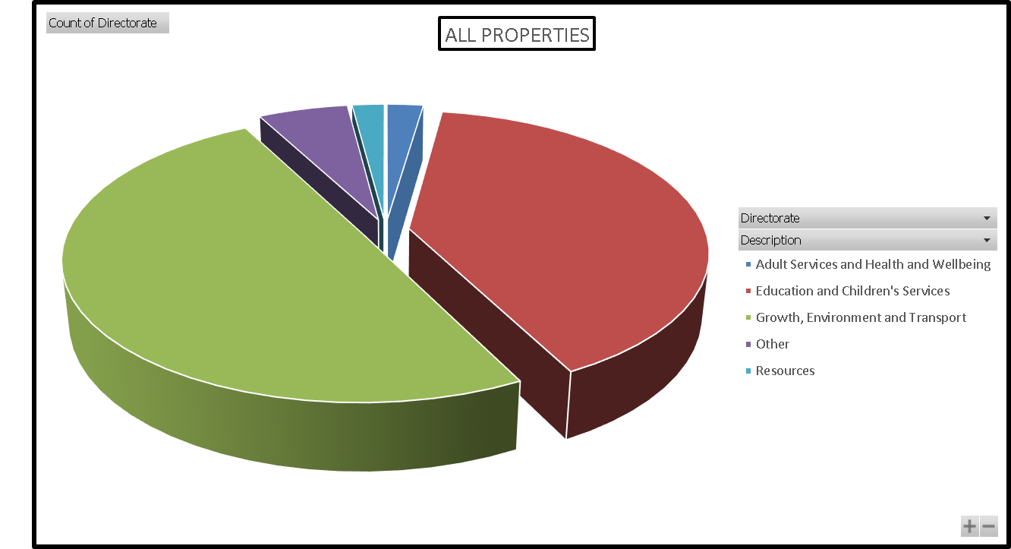
This second chart shows how the 387 operational premises are utilised by the primary occupying service. It does not show where services are co-located and excludes some 600 schools.

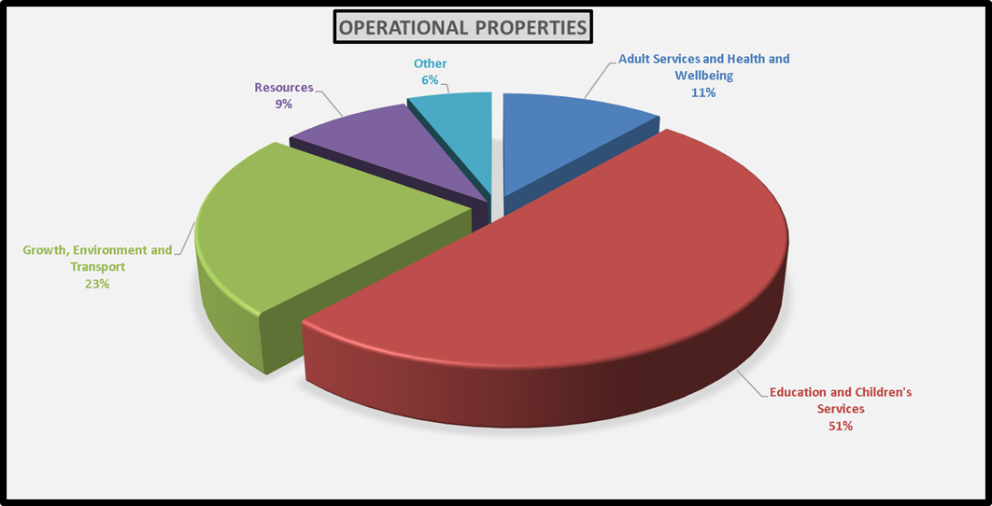

- Risks and opportunities
As corporate landlord, a number of statutory duties are incumbent on the council to fulfil which includes ensuring that appropriate arrangements for premises management are in place and that premises are safe, warm and dry.
This strategy will put in place a mechanism for improved collaboration between services and shared accountability for the management of the property portfolio. It will also improve occupying services understanding of how premises are managed and their respective responsibilities, as well as giving clarity on how requests for change, repair and improvement can be brought forward for consideration as part of a managed process of prioritisation.
This is not a static document but a strategic approach which actively looks for future opportunities to enhance and adapt the portfolio. Not only is it necessary to support current service delivery but also to be flexible enough to take advantage of trends, developments in technology and the environment in order to understand the potential opportunities and impact on how property assets are utilised.
Use of third party premises may be more appropriate where the council's assets do not meet need or where the integration of services with those of partners necessitates a different approach. The One Public Estate and One Partnership programmes are just two of the strategic opportunities that are available and it is likely that others will emerge.
It is important that as a council action is taken to address the climate change agenda and reduce carbon output whilst moving towards a more sustainable portfolio which contributes to the economic development of the county. This not only entails working towards the carbon neutral operation of buildings and energy use but operationally aiming to minimise the need for staff travel as well as public travel in order to access council services. Such an approach links to the digital agenda in addition to a review of the locations from which the council operates.

- Asset management objectives
The property portfolio provides many of the physical locations through which the council is able to meet the needs of service users, and to protect and support vulnerable children, young people and adults. They also provide a place in which people are able to connect with their local community and access culture, heritage and the Lancashire landscape. Investment in these assets can enhance our ability to attract and retain staff, support economic growth in the county and generate income where appropriate.

The following priorities set out the key commitments and activities necessary to meet the property asset management requirements of the council. They will be kept under review to ensure that our approach to asset management keeps pace with changes in the wider environment and regulatory requirements.

Objective 1. Our premises will be safe.
- Premises managers will be supported to ensure they can carry out clearly defined responsibilities with appropriate guidance.
- We will monitor premises compliance against a range of statutory and regulatory requirements across the portfolio
- We will ensure that we keep up to date with changes in legislation and regulation.
- We will apply appropriate occupancy standards for our buildings to ensure that we make the most effective and efficient use of the space available whilst maintaining appropriate accommodation standards for our staff, customers and clients.
- We will ensure that our private finance initiative (PFI) contracts which provide a number of school premises are effectively managed with appropriate client side resource.

Objective 2. Our premises will be maintained to an agreed standard.
- We will carry out a regular programme of condition surveys over a five year cycle with additional inspections as appropriate to particular asset groups.
- We will provide a forward plan of condition related repairs and maintenance based on clear set of prioritisation criteria (Annex 2) and lifecycle management that will minimise the need for urgent works.
- We will provide a reactive maintenance service for unforeseen repairs within an agreed framework.
- We will manage our heritage assets in line with relevant legislation and the nature of their use through the application of appropriate design standards and materials taking into consideration potential ongoing risk to the property.
- We will manage our land and countryside assets in line with relevant legislation and the nature of their use.
- We will identify a minimum standard for the maintenance of specific groups of assets.
- We recognise that a number of our premises provide a short-stay or permanent home for some of our most vulnerable children, young people and adults, and will ensure that they are maintained to an appropriate standard which takes account of this important fact alongside Ofsted and Care Quality Commission recommendations.

Objective 3. Our premises will be suitable for service delivery.
- We will carry out a planned programme of property reviews of our accommodation in line with agreed service strategies to assess location and premises suitability.
- We will maximise use of our premises to ensure value for money in the retained portfolio.
- We will provide a forward plan of suitability works to ensure services are accessible and able to deliver as necessary.
- We will facilitate premises use by partners and communities as appropriate.
- We will ensure there is a high quality school place for every child in Lancashire that wants one
- We will ensure that we have suitable and sufficient accommodation for care service provision.

Objective 4. Our premises will be managed to reduce energy consumption and reduce the carbon footprint of the council.
- We will install energy efficient infrastructure and systems where possible and green energy generation systems where appropriate as part of our planned capital programme.
- We will encourage ways of working which reduce energy use in our premises.
- We will procure green energy supply through our contracts.
- We will utilise digital solutions and location criteria which maximise the accessibility of our services and minimise the need to travel to our premises where possible.

Objective 5. When our premises are no longer required for delivery of our services they will be considered for alternative objectives or disposed of in the most appropriate and timely way possible. In particular, surplus assets may be reused; redeveloped; or disposed of; or new assets acquired; for economic development purposes.
- We will consider whether assets should be retained or disposed of such as for /to public sector partners for delivery of services or other public sector uses
- We will identify assets including acquisitions that present redevelopment opportunities or can support economic growth in the county.
- When no longer required for delivery of services, we will consider retaining, reusing, preparing (e.g. demolition) or disposing assets for economic development purposes,
- We will maximise income from third party use of surplus assets;
- We will consider opportunities for community asset transfer in appropriate circumstances and put such arrangements in place at the earliest opportunity
- We will ensure that disposals take place as quickly as possible to reduce ongoing liability for premises costs.

- Governance and performance management
A Property Asset Management Board will be established to provide oversight and guidance and ensure that programmes and schemes of work put forward for decision making are underpinned by a clear evidence base. Progress against the delivery plan will be reported by exception, highlight, risk and opportunity.
The board will provide effective challenge to ensure that resources are efficiently used, that the provision of space meets the expected standards and that requests for projects achieve value for money. It will also determine where it is necessary to carry out formal consultation if proposals represent a substantial change or where there are potential equality impact considerations.
The board will include representation from:
- Director of Strategy and Performance (chair)
- Head of Service: Asset Management (business manager)
- Asset Manager/s (programme management)
- Director of Finance
- Head of Service: Design and Construction
- Head of Service: Estates
- Head of Service: Commissioning (start well)
- Head of Service: Commissioning (live well, age well)
- Director/Head of Service: Economic Development

To ensure momentum and pace is maintained in implementation of the asset management strategy and delivery plan there will be a clear system of performance reporting established to include:
- Progress reports to the Property Asset Management Board and Corporate Management Team (Performance Board)
- Annual report setting out a deep dive performance review to Cabinet Committee on Performance Improvement
- Key metrics to be reported to the Resources Financial Management Board

- Finance and approvals
The financial requirements associated with the delivery of this strategy will be set out in the capital delivery programme, medium term financial strategy and specific delivery programmes as they are developed. The approval process will follow that of the capital strategy and include the following elements:
- Development of an annual business cycle that incorporates service and geographic based property reviews, priorities identified from condition survey and lifecycle requirements, premises management information and the requirement to provide additional school places. Project requests will be appraised to ensure that recommended programmes of work are promoted by the Property Asset Management Board.
- Draft programmes will be submitted to Capital Board where proposals for funding will be assessed.
- Recommended programmes of work will be reported to Cabinet for consideration and decision making.
- Where a need for works is identified outside of the programme setting process then business cases will be considered by exception as per the capital strategy. This may include where the identified risks associated with not carrying out the works may result in harm to users of the premises or damage to the reputation of the council and cannot be mitigated otherwise.

- Implementation
This strategy will be supported by an asset management delivery plan that will detail the actions necessary to ensure that the priorities set out are delivered against clear milestones and targets.

Annex 1: Policies and operational guidance

Set out below is a range of policies and operational guidance which is either in place of will be developed as part of the property asset management strategy delivery plan. This includes but is not limited to:

- Premises use policy, 2018
- Community asset transfer policy, 2016
- Vacating premises procedure
- Principles underpinning capital investment in schools, 2020

In development:

- Property asset management strategy delivery plan
- Requests for projects and property review process
- Premises compliance policy
- Energy policy
- Review of existing premises manager guidance and training

Annex 2: Premises condition prioritisation criteria

The following criteria is adapted from Department for Education guidance on the management of school building condition and applies equally to the management of the wider retained portfolio.

- Existing condition grading
The condition of each element should be assessed, using the following recommended grades:
- Grade A (Good) - Performing as intended and operating efficiently.
- Grade B (Satisfactory) - Performing as intended but exhibiting minor deterioration.
- Grade C (Poor) - Exhibiting major defects and/or not operating as intended.
- Grade D (Bad) - Life expired and/or serious risk of imminent failure.

- Priority grading
Once the condition of premises has been assessed, priorities should be allocated according to the seriousness of the condition revealed and the urgency associated with any breaches of legislation. This should have particular regard to the possible consequences of deferring works.
The following priority grades are recommended in the context of a five year planning period:

Priority 1. Urgent work that will prevent immediate closure of premises and/or address an immediate high risk to the health and safety of occupants and/or remedy a serious breach of legislation.

Priority 2. Essential work required within two years that will prevent serious deterioration of the fabric or services and/or address a medium risk to the health and safety of occupants and/or remedy a less serious breach of legislation.

Priority 3. Desirable work required within three to five years that will prevent deterioration of the fabric or services and/or address a low risk to the health and safety of occupants and/or remedy a minor breach of legislation.

Priority 4. Long term work required outside the five year planning period that will prevent deterioration of the fabric or services

